**Hong Kong Institute of Vocational Education (Lee Wai Lee) Department of Information Technology**

Higher Diploma in

Cloud and Data Centre Administration (IT114115)

**Final Year Project (ITE4106M) –**

**Interim Report**

**Academic Year 2020/21**

**Date: 7 May 2021**

Cloud based Datacenter Access System

|  |  |
| --- | --- |
| Supervisor: | Kitson Cheung |
| Industrial Mentor: |  |
| Students: | Chan Ka Hei  Lau Wai Hang |

We declare that this is a group project and that no part of this submission has been copied from any other student’s work or from any other source except where due acknowledgement is made explicitly in the text, nor has any part been written for us by another person.

|  |  |  |
| --- | --- | --- |
| **Student** | **Contribution to the project (%)** | **Signature** |
| Chan Ka Hei | 50 | Chan Ka Hei |
| Lau Wai Hang | 50 | Lau Wai Hang |

# ABSTRACT

With the rapid development of information technology in Hong Kong, and many foreign companies have also moved to Hong Kong, under the rapid development of Hong Kong's information technology, many Internet companies have opened data centers in Hong Kong, but traditional data centers are not as popular as modern data centers. We will make a data center remote opening computer cabinet door system. Users in the company, home, or on the street can use this system. You can also use this system to remotely open the data center motor cabinet door brain. The user can use the computer when the computer needs maintenance.  Open the data center cabinet door remotely to provide it to the maintenance personnel. Therefore, you do not need to use the key to open the computer cabinet door. There is no need to worry about the risk of losing the key. We hope this system can help different data centers in Hong Kong. This system, because we are in the internship when a customer visits our data center, we need to walk to the computer cabinet door of the data center and use the key to open the computer cabinet door. It is not smart and convenient. Therefore, this annoying This is the main purpose of our project design.… Therefore, our project is a solution to this problem.

# ACKNOWLEDGEMENT

* Mr. Cheung Wai Kit as our Final Year Project Supervisors.
  + Provide information and opinion
* _________ as our EIA/IA company
  + provide real environment for learning

# TABLE OF CONTENTS

Contents

ABSTRACT 2

ACKNOWLEDGEMENT 3

TABLE OF CONTENTS 4

1. Introduction 6

1.1 Overview 6

1.2 Objectives 10

1.3 Literature Survey 11

2. Project Background and Problem Analysis 12

2.1 Scope of the problem 12

2.2 Problem Statements and description 13

3. Research of Solutions 14

3.1 Advantages 14

3.2 Limitation 15

4. Proposed Solution 16

*4.1* Scope of the proposed solution 16

4.2 Scope of the proposed solution 17

4.3 System Architecture of the proposed system and roles of hardwares 18

4.4 Advantages and drawbacks of the solution 19

5. Requirements 20

5.1 Roles of Users 20

5.2 Functional Requirements 20

5.3 Non-functional Requirements 21

5.5 Language/platform 21

6. Documentation for Problem Analysis 22

6.1 Use Case Diagrams of the whole systems 22

6.1.1 Design 22

6.2 Fully Dressed Use Cases 23

7. Documentation for Detailed Design 24

7.1 Database design (ERD) and metadata 24

7.2 System design (Data Flow Diagram, Class Diagram, etc.) 26

7.3 User interface design 27

8. Implementation 37

8.1 Test plans and results 37

8.2 Changes to design and justification of changes (if any) 37

9. Results and conclusions 38

9.1 Summary and critical discussion of the results 38

9.2 Limitations of the final products / solution 38

9.3 Problems/difficulties encountered and solutions 38

9.4 Delays/changes in project schedule 38

9.5 Suggestion of further improvements / development 38

10. Project Progress and Schedule 39

10.1 Proposed project schedule update 39

10.2 Completed deliverables and future deliverable 40

10.3 Software tools, facilities and hardware are needed during development 60

10.4 Comparison of development and production environment 60

11. References 61

Appendices A : Log Book 64

# Introduction

## Overview

With the rapid development of information technology in Hong Kong, and many foreign companies have also moved to Hong Kong, under the rapid development of Hong Kong's information technology, many Internet companies have opened datacenters in Hong Kong. So, the security of the datacenter has also become a fanatic in the industry. In enterprises, most company secrets are also stored in the datacenter, so the security and safety of the datacenter are also especially important. Otherwise, it is highly likely that the secrets stored by different companies in the datacenter will be transferred to the Internet or the data will be illegally stolen by other personnel in the datacenter, leading to company losses.

Regarding the customer's data should be more protective, this privacy data will be leaked. This incident in the enterprise cannot be appearing. Although there are not any local database or server hackers will not hack and steal easily. We need to ensure the cloud should be more secure. In this aspect, we need to use the correct structure to build it. Moreover,

we need to avoid staff admin have no permission to change cloud services incorrectly. So, we

need to follow the principle of least privilege policy to give them access to the cloud.

## Objectives

During our internship, we learned about the daily management of the datacenter, and learned that large enterprises have spent a lot of thought on designing the security and ensuring the normal operation of the datacenter. For example, you need to apply to the company early before entering the datacenter, and the identity of the other party needs to be authenticated during the visit to ensure that the identity is correct to be able to enter. However, when we use the public FM Intranet system, we think that this system is not smart enough. For example, whenever someone visits and needs authentication, we can only call through security Confirm identity. So, we want to design a system where when someone visits, the security can confirm the identity by entering the other party's ID card, and it is no longer necessary for the security to talk on the phone to confirm the identity, reducing time wasted.

## Literature Survey

We did an online survey and found the following systems related to our project.

#### Research partA

#### 5 Best Practices for Access Control in the Data Center

#### <https://www.vxchnge.com/blog/access-control-in-data-center>

#### Track Assets with DCIM Tools

Asset tracking is a key element of access control. With datacenter infrastructure management (DCIM) tools like vXchnge’s award-winning in\site platform, colocation customers can always monitor the location and status of their assets. They can receive notification alerts whenever something moves or when someone accesses hardware installed in a cabinet. These systems often track historical data, making it possible to create a record of who accessed collocated hardware and when they did so, which can be checked against other records to ensure that every access was indeed authorized and necessary.

#### Research partB

#### Physical security of a data center

#### https://www.isa.org/intech-home/2020/march-april/departments/physical-security-of-a-data-center

#### Strengthen access control systems.

As an outcome of the audit checks, any facility requiring extra protection should receive additional security. For example, multiple verification methods for personnel entry into a certain area may be recommended, such as an access card and fingerprint or retinal recognition. Make an audit of the entire facility to check if the access control system needs to be tightened.

#### Research partC

#### What Are the Most Important Data Center Security Standards?

#### <https://www.vxchnge.com/blog/data-center-physical-security-standards>

#### Access Lists

While it may seem like a simple thing, one of the most crucial elements of datacenter security is ensuring that only authorized persons are permitted to access key assets. When a company collocates with a datacenter, not every employee there needs to have access to the servers. This is a critical component of the “Zero Trust” security philosophy. By maintaining up-to-date access lists, a facility can help their customers prevent theft and guard against human error by people who are not authorized to handle IT assets in the first place.

# Project Background and Problem Analysis

## Scope of the problem

An imperfect access control system has a great chance of causing others to imitate company employees and enter the datacenter to illegally steal data from the company's computers, leading to the leakage of company data. and it will let their company affected. For this we need to take responsibility to Compensate the company for its losses.

## Problem Statements and description

In Hong Kong, the number of datacenters has been growing, because many multinational companies also set up headquarters in Hong Kong. But take our company as an example. Whenever there is a visitor to the datacenter, the security needs to call us for identity verification. Therefore, our project is a solution to this problem.

The purpose of this project is to whenever there is a visitor to the datacenter, the security needs to call us for identity verification. Therefore, our project is a solution to this problem. We hope to design a new visitor system for the company so that the security can directly authenticate with visitors and replace the existing system. Because the existing system is inconvenient to use, the new system can ensure that visitors are authorized to enter, to avoid illegal entry. In our project, we use Flask-AppBuilder as the framework of the webpage and use Flask-SQLAlchemy or Amazon DynamoDB to store the personal information of customers.

And design Show Stay Record and View Last 7 Days Records pages for employees to view on-site visitor information and view the past 7 day, it can protect us let us know who we passed and know they stay here how long. Such as, one day A company engineer come to fix their server and we get the access pass from their company. So, we let him go in at the application time. But A company call in us to company because the server down. then we can check what happen, since is the A company engineer when he is fixing the server time remove the network cable, so it makes the server down.

Since we have the record so it can protect us do not need to take responsibility for this

We also design GID Details to make it easier for employees to understand customer information. it can let us know quickly which server this company is put and where gone happen so we can act quickly.

# Research of Solutions

## Advantages

* [**Hikvision - Easy to Manage and Operate**](https://www.hikvision.com/hk/products/Access-Control-Products/Face-Recognition-Terminals/)

<https://www.hikvision.com/hk/products/Access-Control-Products/Face-Recognition-Terminals/>

Using face recognition to access datacenter.

For now, we use the table to record who can come in the datacenter and when they come in, we need them to sign their name ID card and what company, then the secularity will in put their Information to the temporary visit then we can check can they come in. if they can then they can go in do their thing

For this step is quite trouble so we now go to use face recognition to upgrade our system to let them can come in easily. And it can reduce our workload to let us can do another work quickly. Since we do this check action, we need to spend more 3 to 4 mines. So, if we can skip this step, we can have a higher work efficiency.

And for this we can reduce the manpower. For now, we have two to three securities are on duty. But so many times they just need to stay in the security room and just need to call in when there are people coming in. So, if we can use this system, we can reduce the number of people on duty just let them handle some come in case cannot use the face recognition. Also, when we reduce the manpower, we can reduce the expense too. Since we do not need to keep so much security on duty, it means that we do not need too much security. Then we can cut the manpower to reduce expense.

this system also can reduce the chance of impersonating others. For now, we are use the security to record their ID card number, name and company. For that information it quite easy to get. It may be some one steal the ID card then impersonate others, after checking the name and ID then he can go into the datacenter, activity it is quite danger. But when we use this system, it can let the possibility become lower.

## Limitation

Using face recognition to access the datacenter is very convenient and fast, but only people who have collected faces can enter. This will cause inconvenience to the same company but different employees when they enter the datacenter for the first time because the faces are not collected and cannot be confirmed. At the same time, collecting faces will lead to many privacy issues, not everyone is willing to provide.

Also, some of the customers will send a server engineer (such as: DELL) to come in. But they net every send the same engineer to come in, so we also need to use the security to call in and then we let him go in. So, for this problem, we still have this way to check them

It is a new system, so for this is finish when we go to test there may still have many bugs and errors we need to fix. So, the actual use time may need to delay

And for the first time come in we need to do more things. First, need to check are they are authorized can add they in the face recognition and need to spend some of time to do the face record. Activity if only have some people can be acceptable but when there are so many people come in at the same time, it will make us have more workload.

# Proposed Solution

# Scope of the proposed solution

**Functions**

* **Login System**: Staff can modify guest information. Security guards can view guest register records.
* **Reset Password System**: Staff has an email address to change or give back the password.
* **Language System**: English and Chinese are available for user to use, which is suitable for foreigner.
* **Data Analysis System**: The staff can find out the guest information analysis to understand the guest more.
* **Add to Access List System**: The guest company can register a guest to access list without the need to apply for every visit.
* **Index Page:** Staff can view the homepage and understand how the system works.
* **Face recognition system:** Guest only need to be recognized by the system once when they visit the company for the first time, and then they do not need to be verified by security for the second time.
* **Export data system**: Staff can export the data of the customer's access to the datacenter for storage, and check the records when necessary

**Data**

* Use a MySQL to connect to the database. The database has guest information and customers information and the information of the admin.
* The data will be encryption and save it in database.
* Face recognition data will only be stored locally to ensure that the data will not be leaked
* Staff can check the visit records of the last 7 days on system.
* Staff can view daily access records on the system.
* Staff can modify customer information in the database, such as visitor name, ID card, phone number, company name, smart card number.

**Non-functional requirements**

* **Text**: Use the text on website, the interface is clearer. Staff easy to understand the function.
* **Image:** Use the image on website, Increase the vividness of web pages.
* **AWS CloudFront:** Use CDN services to speed up page loading.
* **AWS Elastic Load Balancing:** Prevent system failures causing tenants to lose access.
* **AWS Cloud9:** Running and debugging code.
* **Flask-AppBuilder:** web page interface.
* **Flask-SQLAlchemy:** web pageDatabase.

## Scope of the proposed solution

**Advantages**

We chose a cleaner web interface for our admin to use this website easier and more efficient. Therefore, interface and user-friendliness are the most important. We are adding a new function of modifying.

Now days data center management aims to meet the challenges of maintaining, operating and managing complex high-performance data centers today and in the future. Data center facility management integrates the three most crucial factors for the successful completion of data center operations: personnel, documentation, and system management.

Therefore, we make this web to let system be more effective. And user can do jobs much faster.

**Disadvantage**

The general problem is that it is not easy to build a new feature, maybe it only takes a month to build a feature. Therefore, it is important to prepare a timetable for this project. If there is no proper time allocated, it will affect the timetable for another step.

Therefore, we must carefully consider the timetable for allocating work. We need to set our own goals, such as the level of expected results. Secondly, we also need to allocate work reasonably, so we use Gantt charts to plan our project progress and statistical projects to avoid spending too much time to develop a single function, which leads to a lack of time.

## System Architecture of the proposed system and roles of hardwares

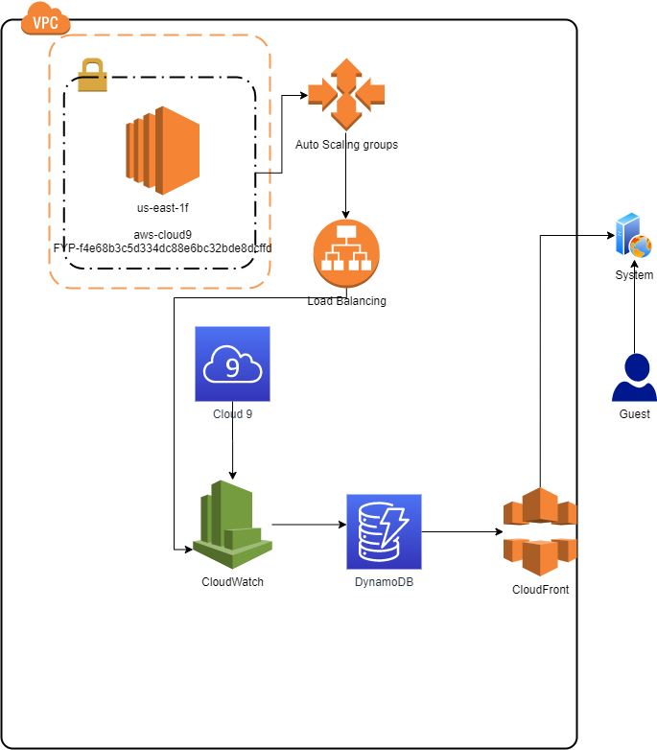

## Advantages and drawbacks of the solution

**Customers**

* No need to wait for security to call us to confirm identity, reducing wasted time.

* You only need to record the appearance for the face recognition system once, and you do not need to identify the security for the security when entering the datacenter in the future, which is convenient and quick.

* Guests can enter 24 hours a day, even when the security guard is not in the office.

* if the company every time call different people come in. it will make the way become complex

* it will make the customer can save the time be more quickly to finish the work do not need spend too much time on the record and search can they go in.

**Staff**

* Only visitors who apply to the company to enter the datacenter in advance can enter, reducing the chance of being copied.

* Even when the security guard is not in the office, when visitors use other people's smart cards to enter the datacenter, they will be blocked by the face recognition system, reducing the chance of visitors being imitated.

* The face recognition system can reduce the workload of security, while increasing safety

* Security can check the personal information and number of guests in real time through the system

* As whom are in the office he can be more focus on the other work, do not need to be too busy on the phone call in.

# Requirements

E.g., Reliability requirements, performance requirements, existing data interface and hardware environment, future extensions of the proposed solution, required implementation language.

## Roles of Users

## The main user is the staff and the security, they can check the come in record and add who need to come in later or in the future days.

## The staff can use this system to check the customer data such as what rack are they have, who are in the access list and the detail of the company. Also, the staff can change the company data for if they change some racks or need to change some access list people

## The security just only can add who now arrivals and cannot do any change for this. And if there are any visitor in here, they need to call the staff to ask can they go in. And they need to notice the staff are there any people go out.

## The customer if he passes the face recognition before then he can keep using this to go in the data center if do not, he just need to provide his name, id and company to security make a record. They need to write down the same id and name from the access email if they fill wrong id or name, it will make us need to spend more time to change the record and pass they come in.

## Functional Requirements

* **Login System**: Staff can modify guest information. Security guards can view guest register records.

* **Reset Password System**: Staff has an email address to change or give back the password. For staff who forget their password can retrieve `the password via email address. To reduce the problem of they can start to work due they forgot the password.
* **Editing system:** Staff can edit the information of the customer by the administrator account for the information of the customer is correctly in anytime.

* **Language System**: English and Chinese are available for user to use, which is suitable for foreigner.
* Staffs can us data to research and find out the information quickly.
* Staff can always modify customers information, such as ‘’name” and “email” and “phone number”.
* Staff can export their customer’s records so that they can check the history records when necessary.

* **Data Analysis System**: The staff can find out the guest information analysis to understand the guest more.

* **Add to Access List System**: The guest company can register a guest to access list without the need to apply for every visit.

* **Index Page:** Staff can view the homepage and understand how the system works.

* **Face recognition system:** Guest only need to be recognized by the system once when they visit the company for the first time, and then they do not need to be verified by security for the second time.

* **Export data system**: Staff can export the data of the customer's access to the datacenter for storage, and check the records when necessary
* bulletin board: Staff can know daily news information to the information interface, so that they can understand the latest news of that day and what can they do.

## Non-functional Requirements

## Make the home page be more beautiful

## Make the output data can let the user watch more easily

## The page background we made it become black, it can let the staff when using its website, he can have a good eyes care. If the background we use the write or other color it may hurt the use to let him cannot keep use this web for the long time.

## For the page can keep vivid so we put some photo in there and the photo can keep move it make the page can have a live and do not make it be bored.

* 1. ***Hardware***

Development PCs

Displays

Network

## Language/platform

Software/platform List

|  |  |
| --- | --- |
| Flask | The main framework of the web |
| Docker | Develop in multi-cloud and save the image |
| PyCharm | An integrated development environment |
| GitHub | For version control using Git and save code |

Cloud Service List

|  |  |
| --- | --- |
| Amazon RDS | For main database |
| Amazon Elastic Container Service | For docker container |
| Amazon Elastic Container Registry | For docker container registry |
| Amazon Lambda | For serverless application |
| Amazon CloudFormation | For provision all the infrastructure resources |
| Amazon Route 53 | DNS service |
| Amazon Cloud9 | An integrated development environment |
| Amazon CloudWatch | A monitoring and management service |
| Amazon Cognito | For control user account |
| Amazon Code commit | For version control |
| Amazon Shield | For resist DDOS attack |
| Amazon Load Balancer | For distribute workload |
| Amazon Auto Scaling | For change or adjust the traffic |
| Amazon Macie | For protect privacy data |

# Documentation for Problem Analysis

## Use Case Diagrams of the whole systems

We are going to using SDLC Model (e.g., Agile, Waterfall …)

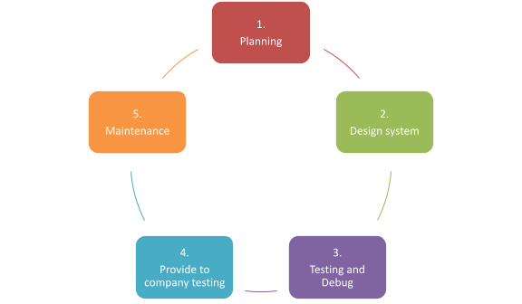

### Design

The design phase of the project began from September, and we will continue making progress on the following aspects:

**Part A**  
Planning set a guest access system in datacenter (FM Intranet)

**Part B**  
Using AWS Cloud9 to build up Flask-AppBuilder.

**Part C**  
Design new website to update guest access system in datacenter (FM Intranet)

**Part D**

Design face recognition technology and link to the system

## Fully Dressed Use Cases

|  |  |
| --- | --- |
| Scope/System | website |
| Name | FM Intranet |
| Level | Easy |
| Primary Actor | Customer, and Staff |
| Stakeholders and Interests | Customer Data  Company Responsibility |
| Preconditions | Customer needs to register with the company |
| Postconditions | After the company is registered, the datacenter can be secured |
| Main Success Scenario | Ensure datacenter security |
| Extensions | Datacenter Access System |
| Special Requirements | Databases save customer data |
| Variations in Technology and Data | Increase and decrease customers |
| Frequency of Occurrence | Every day |
| Miscellaneous | N/A |

# Documentation for Detailed Design

## Database design (ERD) and metadata

## https://lh3.googleusercontent.com/pLK5BCfKi1zfvWnFvu2PZ3VBddZ7hsdnMqJjyRcFjA38swWPKy65vwlStqROQFUYhhNb1AZkXDRPvHiw57tXqNM0bmJQ3gQj5YNS5gUoGUi52vVbX2XiXncSnfbrV5VFvAHTQ2X_G7A

## System design (Data Flow Diagram, Class Diagram, etc.)

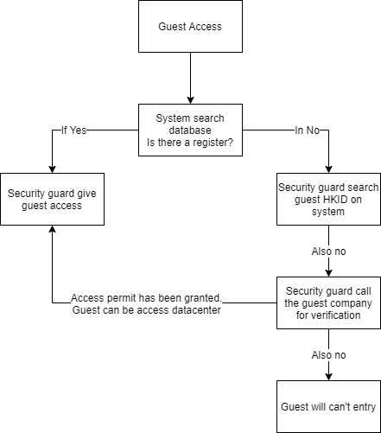

1. When the guest access data center, search the database is there a register access datacenter.
2. If the system searches the database is there have been register. The security guard will allow guest access.
3. If the system searches the database there are not have been register or wrong name, the security guard will search guest HKID for verification.
4. If the system searches the database there are not have been HKID, the security guard will call the guest company to verification.
5. If the guest company can verification guest, the access permit has been granted.
6. Guest can be access datacenter.

## User interface design

* Introduction system (Index)

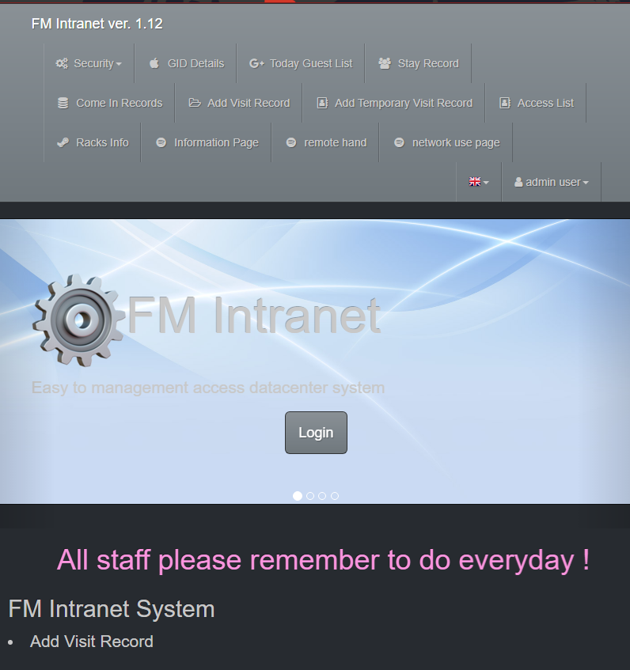

* *Guest Company name list (GID Details)*

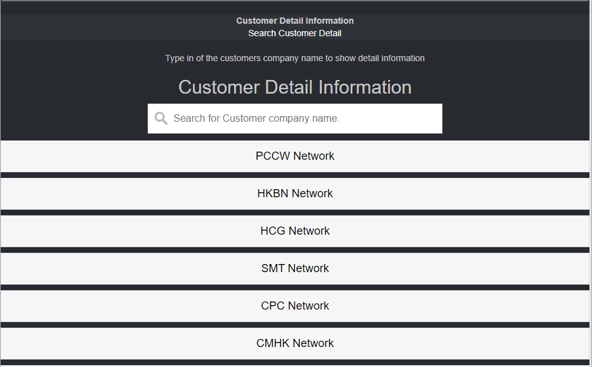

* Today Guest access list (Today Guest List)

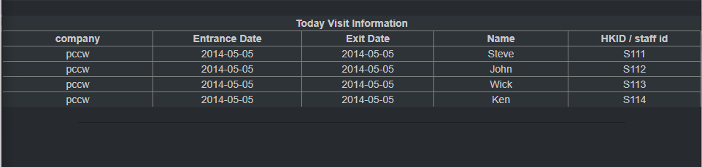

* Guest access stay record (Stay Record)

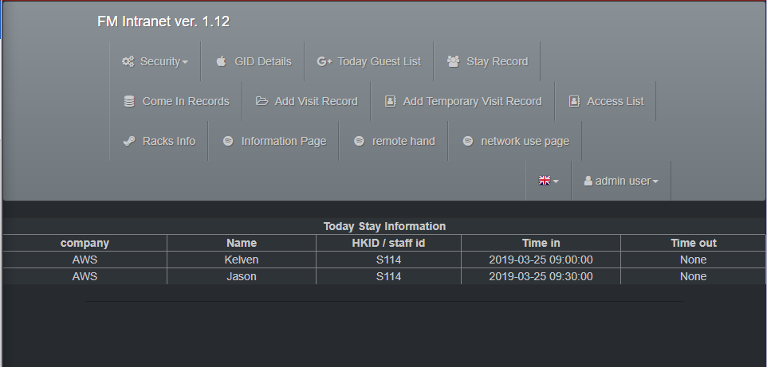

* Guest access records (Come in Records)

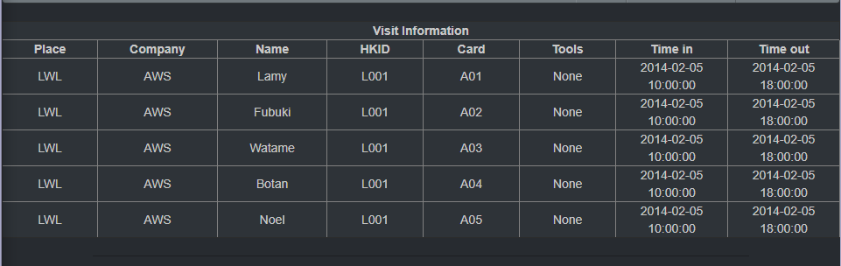

* List all user registry (Access List)

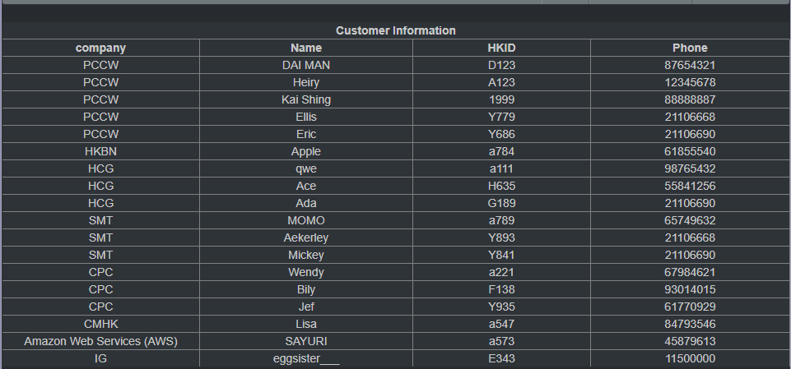

* All guest company racks Info (Racks Info)

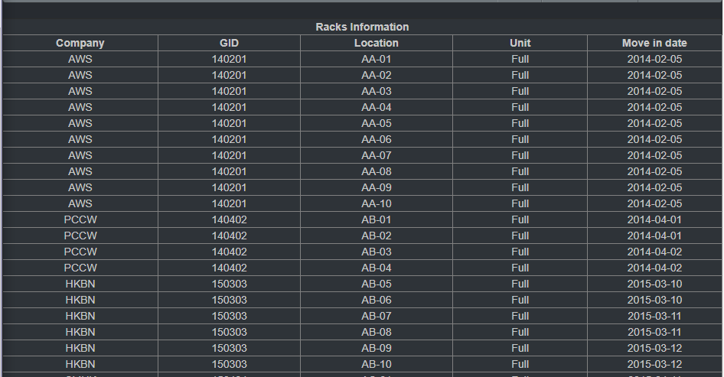

* See customer data page (Information page)

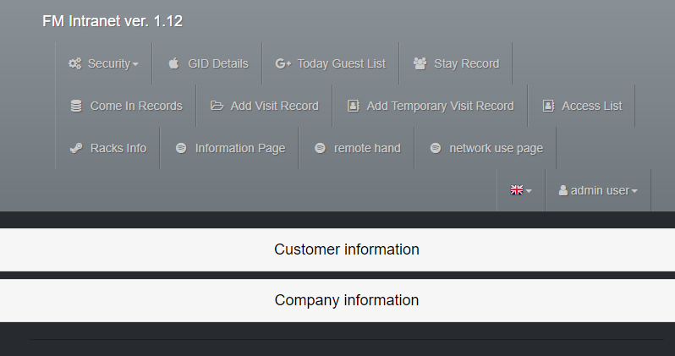

* See customer data page (Customer Information page)

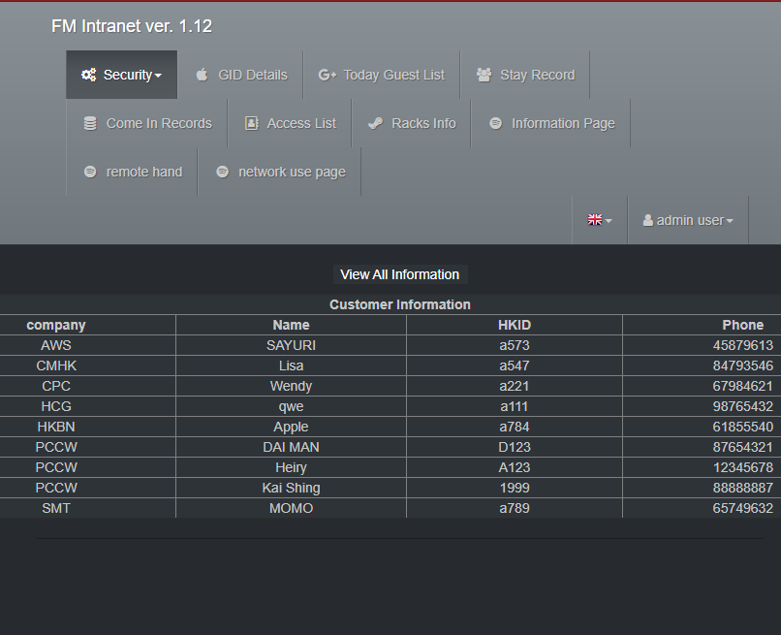

* See customer data page (Company Information page)

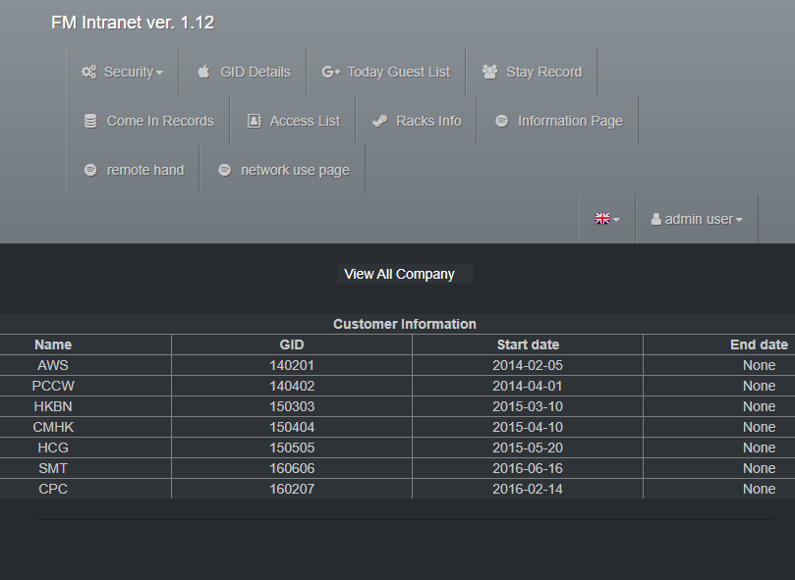

* Record the help thing (Remote Hand)

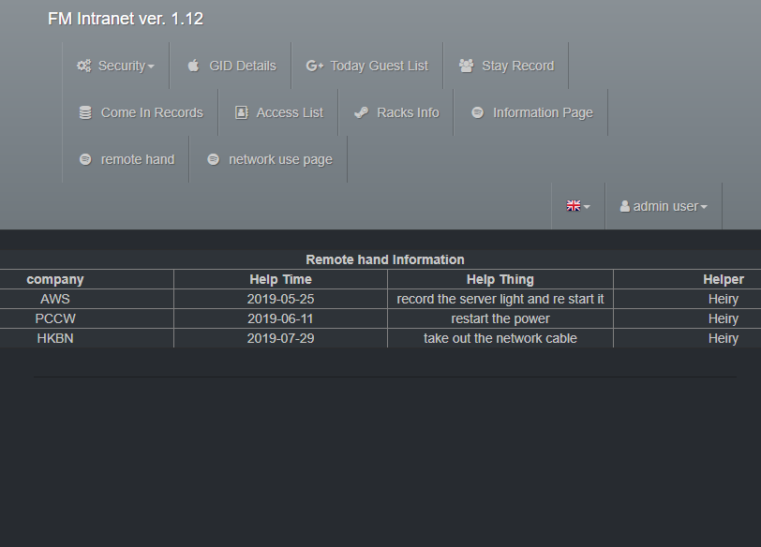

* Check the network use states (network use page)

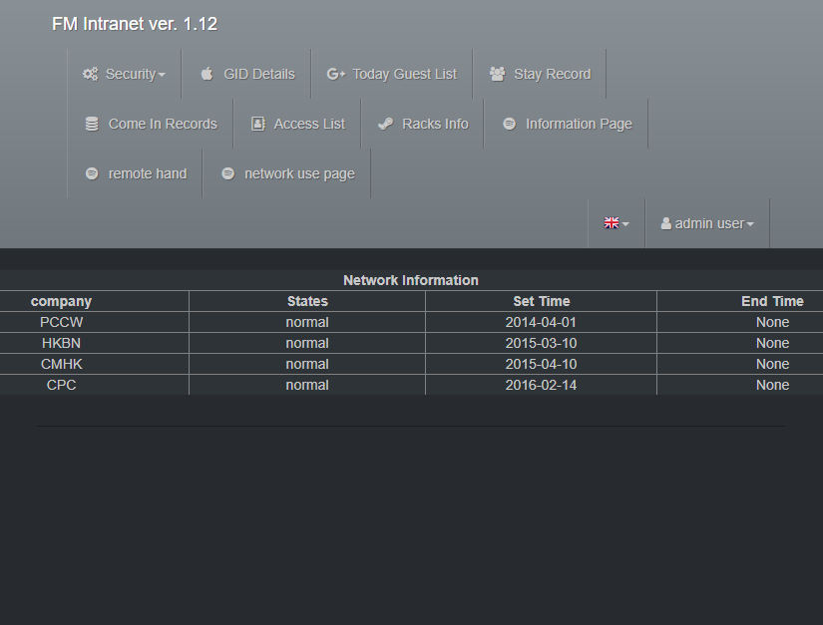

# Implementation

## Test plans and results

Unit tests are run during the development process to ensure that all modules are built correctly. Run system integration tests after building all components Then combine them in the application.

## Test Case (1) @ 04-10-2020

Try to test the database cannot follow the python program to process.

Testing the MySQL cannot build up in the cloud.

Testing the web running status.

Testing the customer interface will not collect correct data.

Add new web page.

Testing can the php work on the cloud.

function does not work.

Upload source code to GitHub.

## Test Case (2) @ 15-10-2020

Testing the MySQL cannot build up in the cloud.

Testing the web running status.

Testing the customer interface will not collect correct data.

Add new web page.

Testing can the php work on the cloud.

function does not work.

Upload source code to GitHub.

## Test Case (3) @ 02-11-2020

Testing the MySQL cannot build up in the cloud.

Testing the web running status.

Testing the customer interface will not collect correct data.

Testing can the php work on the cloud.

function does not work.

Upload source code to GitHub.

## Test Case (4) @ 30-11-2020

Testing the MySQL cannot build up in the cloud.

Testing the web running status.

Testing the customer interface will not collect correct data.

Testing can the php work on the cloud.

function does not work.

Upload source code to GitHub.

## Test Case (5) @ 16-1-2021

Testing the MySQL cannot build up in the cloud.

Testing the web running status.

Testing the customer interface will not collect correct data.

Testing can the php work on the cloud.

function does not work.

Upload source code to GitHub.

## Test Case (5) @ 30-2-2021

Testing the MySQL cannot build up in the cloud.

Testing the web running status.

Testing the customer interface will not collect correct data.

Testing can the php work on the cloud.

Upload source code to GitHub.

## Test Case (6) @ 12-4-2021

Testing the web running status.

Testing can the php work on the cloud.

Show all child photo function does not work.

Upload source code to GitHub.

## Test Case (7) @ 1-5-2021

Testing the web running status.

Testing can the php work on the cloud.

Upload source code to GitHub.

## Changes to design and justification of changes (if any)

# Results and conclusions

## Summary and critical discussion of the results

We make a cloud web system like our company to manage better.

The system functions they are currently using are outdate and not smart enough. Therefore, we hope we can update this system to increase the usability of the system.

For the record, the old system just only saves for those day. And the older record is needed to go to other website to find, it is raising so much time on this, so we put all the come in record in this website to let people find this easily.

In the old system we need to find so many times to find the contact person so we for this function to make an upgrade, we make a page to show the contact person. It makes us easily to find who need to contact when something happens.

For discussion we make an update to the old system, in every page we also make it easily to see and to be record.

## Limitations of the final products / solution

For this project we are quite hard to write the right code to run this if we are writing some wrong code, we need more time to fix this problem. So, for this we spend so many times on this.

In this project we only have two people, and we also do not have enough knowledge to do this so in this time we cannot make many different functions to show. So, we just make the basic system to show the different table data.

Since for us we are so carefully people, both of us are so carefully to do this project, we do not change the code in the python file easily. We are so scared to break this project when we make something wrong. So, it makes our project be slow progress.

Even we can find different code on the website, but we also cannot complete understand what it is talking about. So even we may find the right code for this project bet we even use this to add.

## Problems/difficulties encountered and solutions

In this project we are quite hard to write the right code to run this if we are writing some wrong code, we need more time to fix this problem. So, for this we spend so many times on this.

Recording that we do not know how to create the table and connect it to the database on the website. So, we spend so many times to search the way to make the table work and connect to the database for the example we search the way to connect a php file to the database to connect or edit the database.

In this project we spend so much time on the database connect. But on this finding way we find some solution can display the data on the website. Final, we success to make the database can use on the website, and for the before result, we quickly to make the full version for the html.

## Delays/changes in project schedule

About the MySQL database and the html, we change this to just only can display the data from data base and it can show quite more result on this.

## Suggestion of further improvements / development

## For the future I think we can add more function in this system such as add the data in there and we can edit the data too. For this I hope it can be success. Also, I hope we can make a change on this project to make the user can watch the only page to edit too.

# Project Progress and Schedule

## Proposed project schedule update

Gantt Chat

|  |
| --- |
| https://lh6.googleusercontent.com/DeTCefef88jwl08HXSoQ7LAsAQEQMbuCvqd4njsiddoAnOjwDE86ppl2ZilUFHdLeIEQ4jhEWBzhsCFQ7A0vh0eVnU6vE_6qkMhmABOHoCqQDpO1KWH2BwlwMxhYdn4kDHFzG8210iU |

We will step by step and will have correct and balancing distribution work to finish this project. In this year’s we will cooperate with groupmate to develop this web system. We hope that the design of this system can help the company upgrade the existing system, make it easier and faster for visitors to perform identity verification when entering the datacenter, and reduce the risk of identity theft to ensure the security of the datacenter.

## Completed deliverables and future deliverable

* Introduction system (Index)

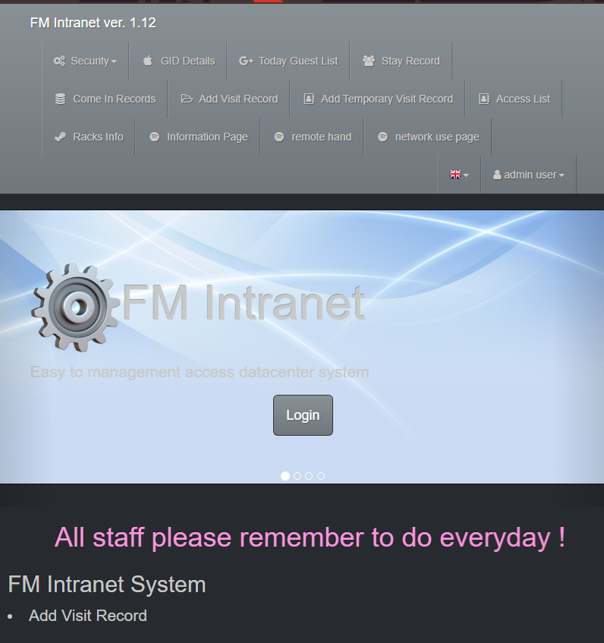

* *Guest Company name list (GID Details)*

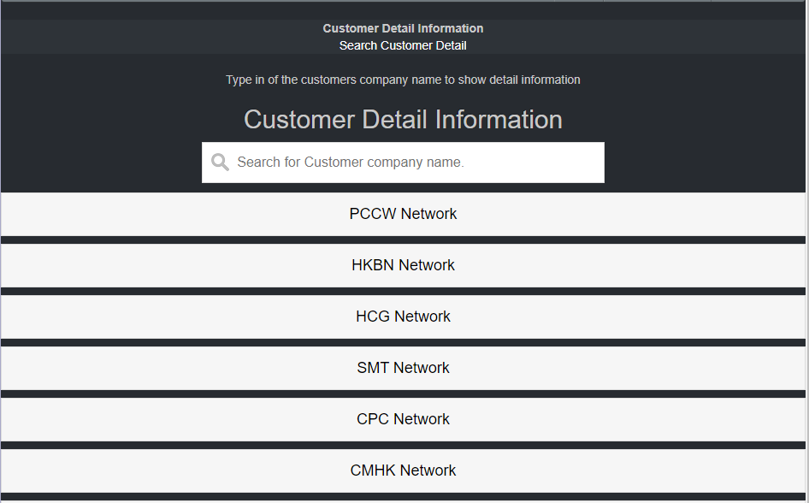

* Today Guest access list (Today Guest List)

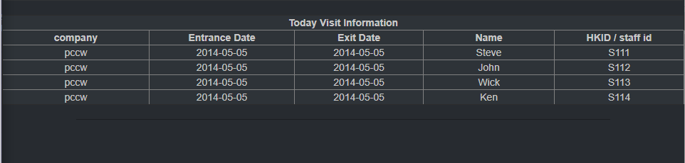

* Guest access stay record (Stay Record)

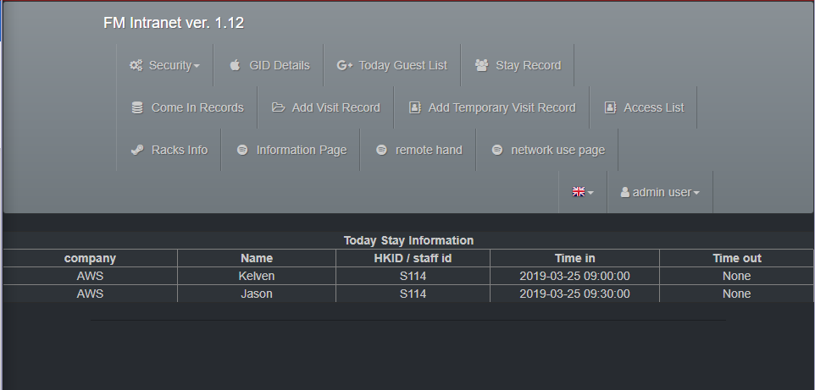

* Guest access records (Come in Records)

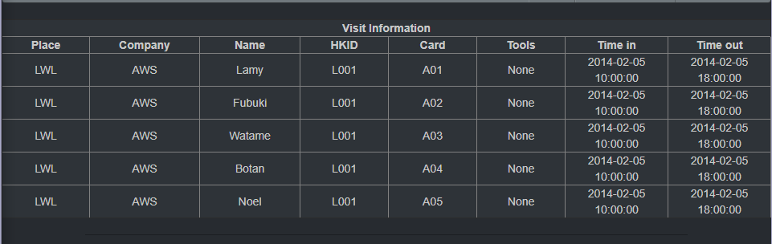

* List all user registry (Access List)

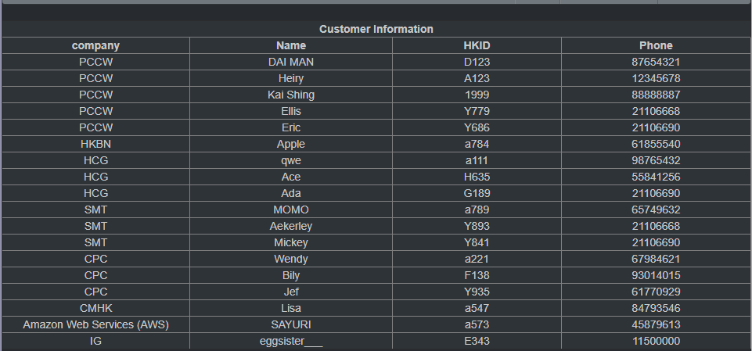

* List all guest company racks Info (Racks Info)

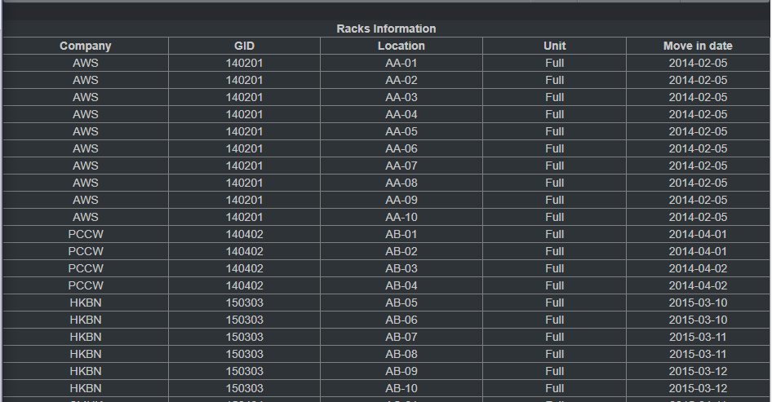

* See customer data page (Information page)

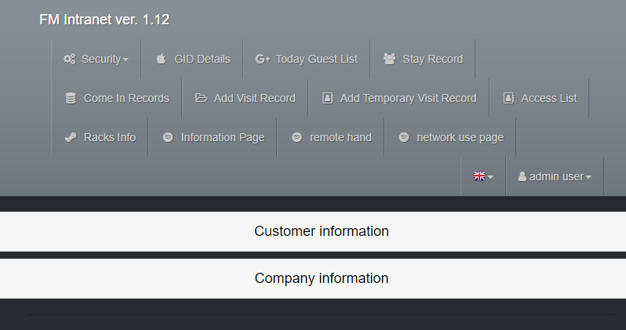

* See customer data page (Customer Information page)

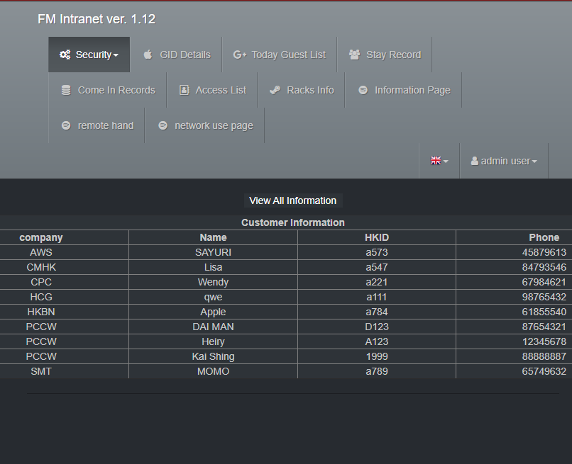

* See customer data page (Company Information page)

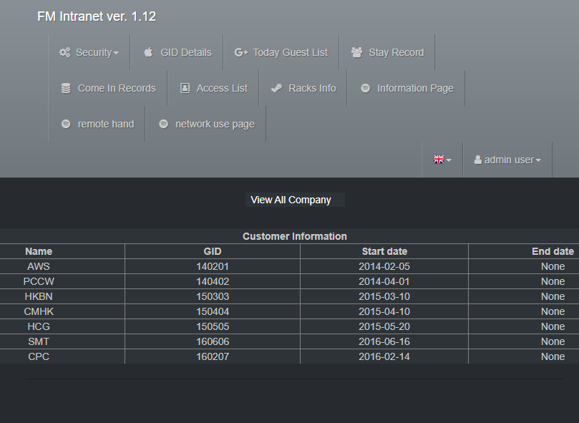

* Record the help thing (Remote Hand)

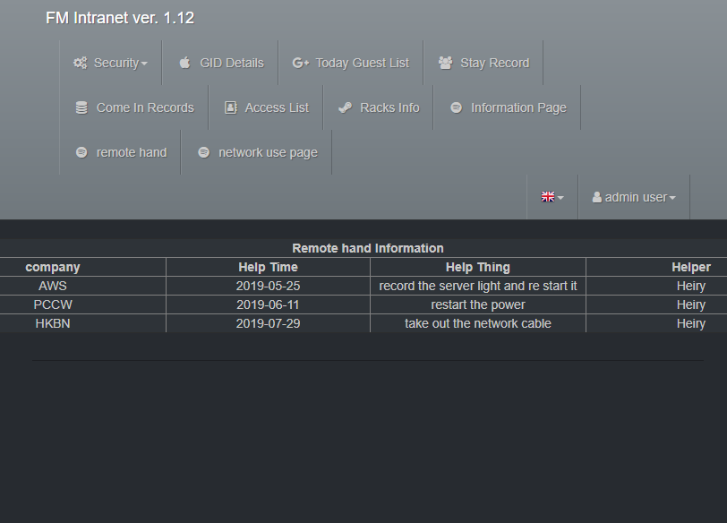

* Check the network use states (network use page)

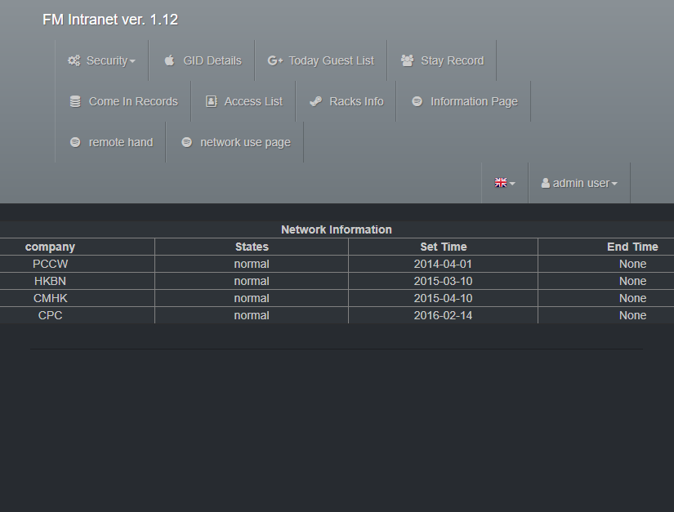

***Page:***

* Introduction system (**Index**)



The homepage introduces the functions of this system and staff notes

* Guest Company name list (**GID Details**)



This page displays the company information of all visitors.

* Today Guest access list (**Today Guest List**)



This page shows the number of customers released today and their personal information for reference.

* Guest access stay record (**Stay Record**)



This page shows all the people in the datacenter.

* Guest access records (Come in Records)



This page displays the visit records of all visitors in the past seven days.

* Search guest are their registry (**Access List**)



This page can query the registration status and personal information of the visitor by the visitor's name or company name.

* List all guest company racks Info (Racks Info)



This page can search for related racks information by racks status, rack's location, company name.

* See customer data page (Information page)



This page can go to edit different customer ‘s data such as customer access list, Rack's info and any remark.

* See customer data page (Customer Information page)



This page shows the customer information, is about when they buy our servers and who is the customers of this company

* See customer data page (Company Information page)



* Record the help thing (Remote Hand)



This page shows the record we go to help the customer

* Check the network use states (network use page)



This page shows the network using states in our datacenter

This page shows the database status and all table on website.

## Software tools, facilities and hardware are needed during development

|  |  |
| --- | --- |
| AWS Cloud | Develop a cloud service |
| PyCharm | An integrated development environment |
| GitHub | For version control using save code |

## Comparison of development and production environment

Strategies for managing multiple environments:

To implement mission-critical projects in an organized manner, organizations often maintain separate development and testing environments before releasing the project to the production environment. Although you can copy the same Warehouse Builder project across environments, you usually need to assign different physical properties to each environment. For example, when loading the target table in a production environment, you may want to save all error messages to a log file. However, when loading the target in the development environment, you may decide not to save the error message.

In addition, although the same logic design can be copied initially in each environment, these designs can be developed separately. In the development environment, the development team continuously implements new features and makes changes to improve performance. In a production environment, based on the discovery and correction of errors, the design develops slowly in a controlled manner.

Therefore, to maintain separate environments for development, testing, and production, it is necessary to use the same logical design in different physical environments and manage any differences in the design in these environments.[1]

# References

1. 5 Best Practices for Access Control in the Data Center

<https://www.vxchnge.com/blog/access-control-in-data-center>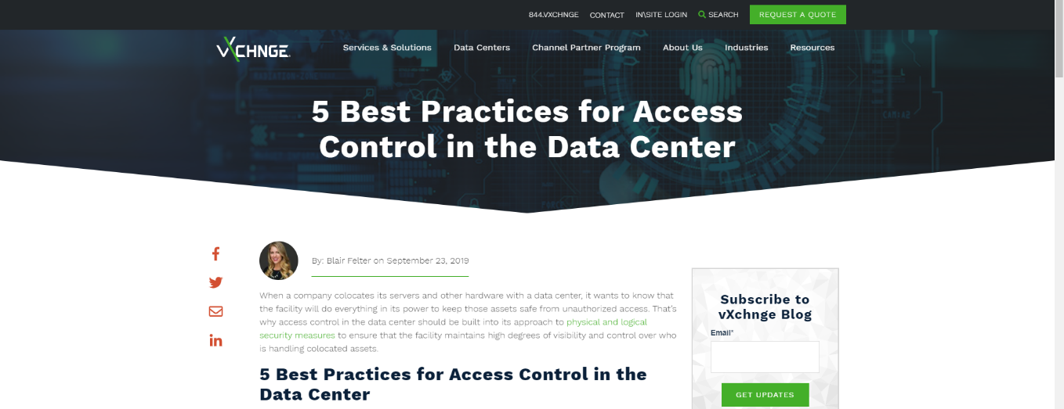

1. Data Centers - Our Controls – AWS

<https://aws.amazon.com/compliance/data-center/controls/>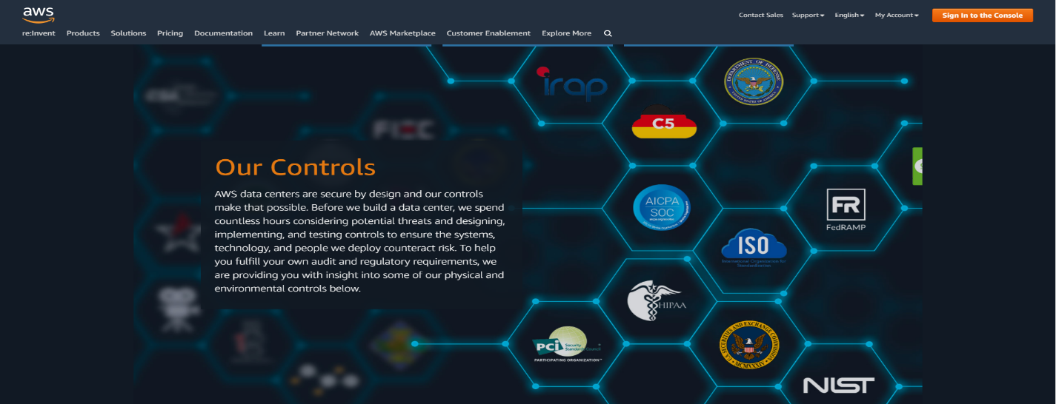

1. 5 Best Practices for Access Control in the Data Center

<https://www.vxchnge.com/blog/access-control-in-data-center>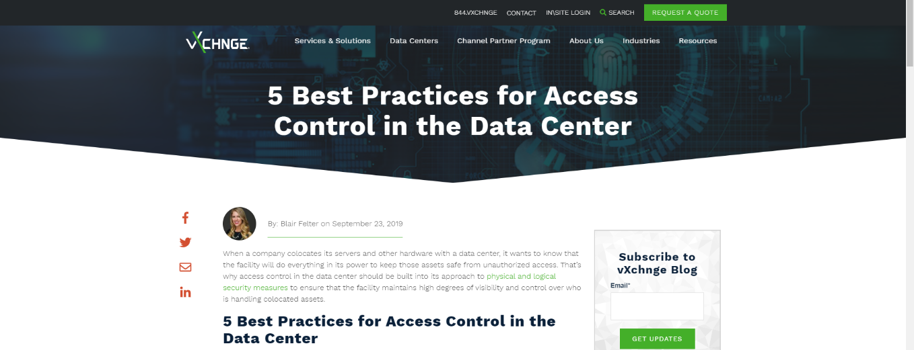

1. Physical security of a data center

<https://www.isa.org/intech-home/2020/march-april/departments/physical-security-of-a-data-center>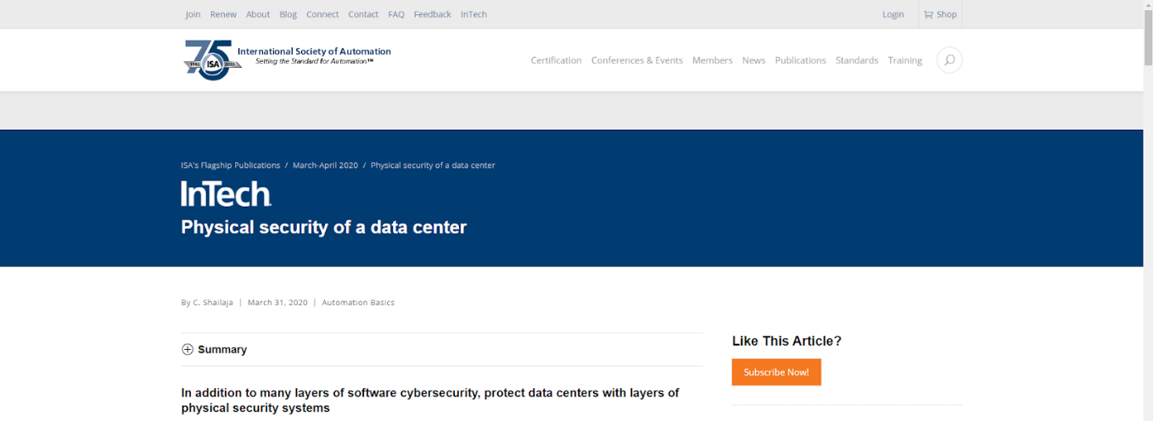

1. What Are the Most Important Data Center Security Standards?

<https://www.vxchnge.com/blog/data-center-physical-security-standards>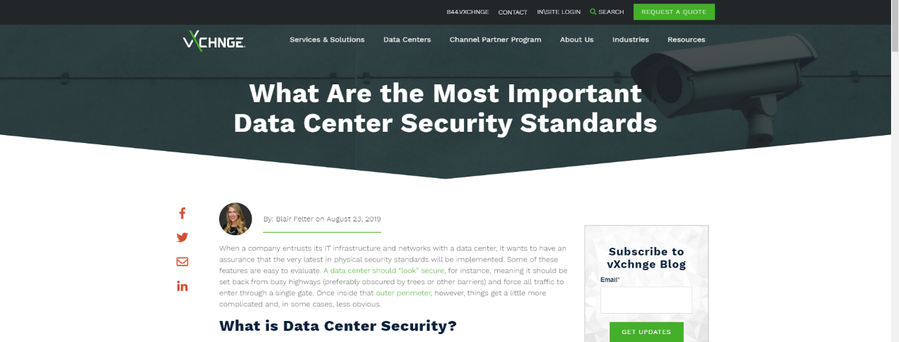

1. Hikvision - Easy to Manage and Operate

<https://www.hikvision.com/hk/products/Access-Control-Products/Face-Recognition-Terminals/>

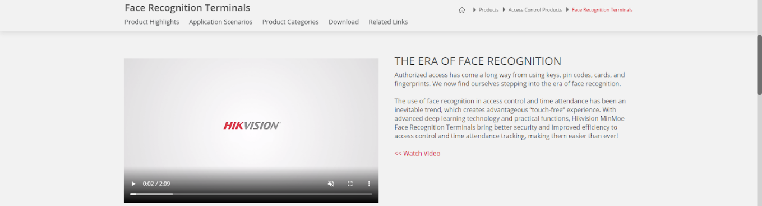

1. Strategies for Managing Multiple Environments

<https://docs.oracle.com/cd/B28359_01/owb.111/b31280/configs_11.htm#WBINS12301>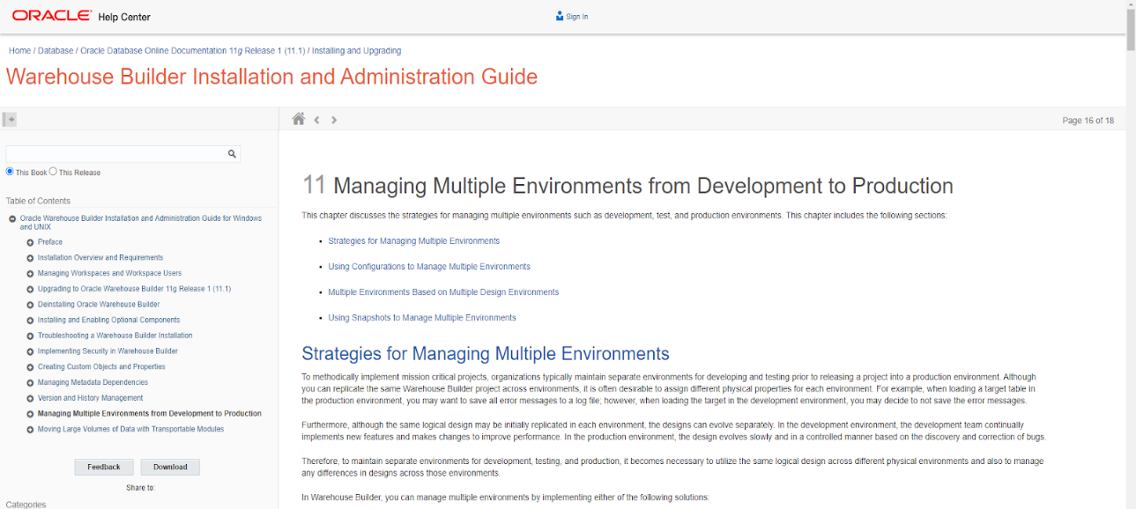

# Appendices A: Logbook

09-11-2020(Mon)

Introduction (1.1 – 1.2)

Project Planning (7.1 – 7.3)

10-11-2020(Tue)

Introduction (1.2 – 1.3.3)

16-11-2020 (Mon)

Project Background and Problem Analysis (2.1 – 2.2)

Research of Solutions (3.1 – 3.2)

17-11-2020 (Tue)

Proposed Solution (4.1 – 4.6.1)

23-11-2020 (Mon)

Non-functional Requirements (5.1 - 5.2)

Software Process Model (6.1 - 6.2.5)

References (1-3)

24-11-2020 (Tue)

Appendices A: Logbook

1-1-2021 (Fri)

Update:

Proposed Solution (4.1, 4.3, 4.6)

Software Process Model (6.2.1, 6.2.3, 6.2.4)

Project Planning (7.1, 7.2)

7-4-2021 (Wed)

Update:

Adding the MySQL database connection to the web

8-4-2021 (Thu)

Add table in MySQL

Add data in table

14-4-2021 (Fri)

Add table in MySQL

Add data in table

17-4-2021 (Mon)

Add table in MySQL

Add data in table

18-4-2021 (Tue)

Update The HTML page

1. <https://docs.oracle.com/cd/B28359_01/owb.111/b31280/configs_11.htm#WBINS12301>